NEWSLETTER November 2020


NEW TELEPHONE SYSTEM IN AVELEY MEDICAL CENTRE!

In response to popular demands about the phone system and difficulties of phone access to the Surgery, we listened to you and have now changed our phone system to a cloud based system and
you would notice the vast improvement when you call the surgery.

We would like your feedback as we put this phone line in place and ask you to bear with us if there are any initial setbacks.

In line with our pledge to improve your experience, we continue to provide care as below:

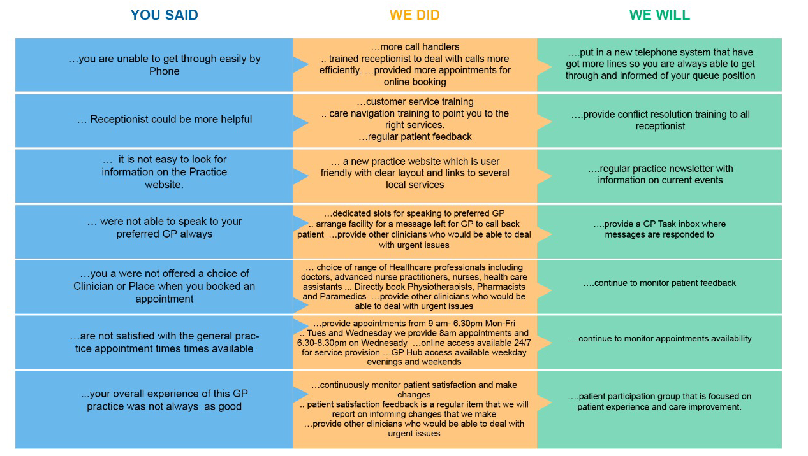

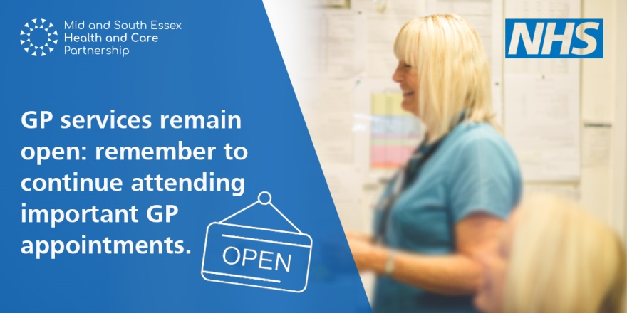
We have now entered into the second wave of lockdown since the Prime Minister’s announcement of 5th November, 2020. During the lockdown, people can still contact their GP practices by calling for appointments as they would normally. Patients who require medical advice will be given a video or telephone consultation and only asked to visit the practice if this is deemed necessary by the clinical team. This will reduce the risk to you and the clinical team and is in line with current lockdown guidance.
It is important that anyone who has symptoms of co-vid 19 does not leave home and this includes going to their GP practice. GP practice staff will be there to provide care for those who need it for all other medical conditions and concerns, including for those with long term conditions and for those needing immunisations. Patients can also continue to access the out-of-hours (evening and weekend) GP services. These appointments can be booked through the Surgery or if the practice is closed, the automated message will contain the number to call for the local out-of-hours service.

There are four main ways to seek healthcare advice from a GP:

- Call the surgery to discuss a face-to-face or virtual (telephone or video) appointment;
- Visit our surgery website and complete a confidential online form via DrLink to receive a response before the end of the next working day;
- Call NHS 111 or go online to seek advice;
- Download the NHS App to order repeat prescriptions, book appointments and check your symptoms.

How to get the most out of your GP appointment?

- Be friendly – to all members of the staff you encounter especially the reception staff. Use polite language that will help you to be listened to.
- Being empowered, your voice counts– remember you are in control of your care. Be confident to talk through why you are there.
- Be prepared –think about what you would like to discuss and the outcome of the appointment.
- Be clear –before leaving your appointment make sure you understood everything that was clear. Write things down if it will help you remember.


We would like to thank everyone for working with us during these unprecedented times, complying with the huge changes we have had made in the Surgery over the last few months. This has helped reduce the risk of COVID-19 infection throughout the Aveley Village and South Ockendon community and we are very grateful for the part you have all played in this.
.




WELCOME

We would like to welcome our two new doctors who have now joined the team in Aveley Medical Centre

- Dr Thullasi

- Dr Aneke

Cancer Screening
One in two people will develop cancer at some point in their lives, according to the most accurate forecast to date from Cancer Research UK. Cancer screening may be your only chance of detecting it early and beating cancer!
Cancer screening is a way of testing healthy people to see if they show any early signs of cancer

SUPPORTING YOUR MENTAL HEALTH and WELLBEING
It is well recognised that the Stress of the Pandemic and loneliness of Social isolation and lockdown can have its toils on our mental health. You do not have to suffer in silence.
Please reach out to the suitable service that best meets your needs.



COVID -19 VACCINE

-Practices on standby for December vaccination drive

The British government wants to begin COVID-19 vaccination early next month if the Pfizer mRNA vaccine can gain approval, health secretary Matt Hancock has said.

The project may lead to reductions in GP services as staff are deployed to run vaccination centres, senior doctors have warned. Mr Hancock conceded that vaccination would be a “mammoth logistical operation” but said news of it would “inject hope into millions of arms this winter.”

He said: “The logistics are complex, the uncertainties are real and the scale of the job is vast, but I know that the NHS, brilliantly assisted by the armed services, will be up to the task. It is next summer before the next vaccine candidate comes on stream and so the focus of the roll out plan at the moment is on delivering the Pfizer and the AstraZeneca projects if they pass the safety tests.”

According to the plans, the NHS would deliver more than a million vaccinations a week, giving priority to the over 65s. Pfizer said yesterday that the vaccines would have an effective life of up to five days when refrigerated at temperatures of up to 8C. It says it has developed containers that will keep the vaccines “ultracold” for up to ten days after they leave their main storage depots, where they must be kept at minus 70C.

